Alice in Lollyland Animations
Estimates and potential choreography
Choreography Document

Summary
Design/Illustration - 40 hours
Special WILD symbol  New look for WILD symbols which have been placed by the X symbol and will leave a border | 8 hours
Spin Count Panel  Shows what spin the player is up to, out of 10 – with the 10th spin triggering WILD STORM | 16 hours
Border  Will remain after X symbol has landed | 16 hours

Animation - 160 hours
WILD  - Setup/rigging  - Idle animation  - Win animation  - Change from border into Wild  Special Wild animation will use normal Wild rigging/tweens but different skins | 48 hours
SPECIAL WILD  - Change into border on next spin | 16 hours
X SYMBOL  - Setup/rigging  - SRS animation  - Change into border  - Change into special Wild during free spins  - idle | 40 hours
SCATTER  - Setup/rigging  - Idle animation  - SRS animation  - trigger animation | 36 hours
Win Box and Windup  We think the hot-pink originally designed for v1 of 10000 YEARS BEFORE CASH would be perfect for this game. We already have the effects | Maybe half hour to alter size? Maybe 0?
Spin Counter Panel  - Add 1 spin to total spins  - Trigger  - reset | 16 hours
Backgrounds | 4 hours

Design/Illustration 40hr
- 8hr Special Wild (different bg, color pallette purple and gold to match X symbol, different hair and bows in hair)
- 16 hr Counting panel (counts which spin player is up to)
- 16hr Border (An open door to the wonderland?
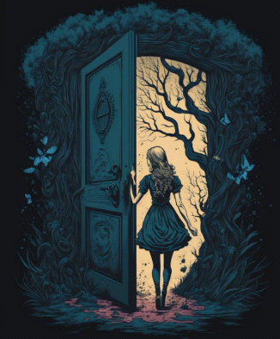
Or maybe we need to emphasise the lolly in the border?
- 4hr Bitmap font for win rollup

Animation 157 hr
Wild
Setup/rigging for ALL wild animations : 16 hr
Idle animation : 8 hr
Symbol |  | Bo  setup 5.30hr  animate 5 hr
Looping | yes
Duration | 5-10 sec
Description | - Subtle moving

Win : 16 hr
Symbol |  | Bo  9 hr
Looping | yes
Duration | 2 sec
Description | - Happy face  - With glow effect  - Text booom!

Special Wild
Change to border: 16 hr
Symbol |  | Bo  5 hr
Looping | no
Duration | 2 sec
Description | - Alice go under the ground (imagine : there is a hole under her feet)  - Then transition come and cover the symbol (Hookah transition)  - Morph into the border (drunk effect)

Idle animation
- hr
Symbol |  | Bo
Looping | yes
Duration | 5-10 sec
Description | Same animation as normal Wild

win
Symbol |  | Bo
Looping | yes
Duration | 2 sec
Description | Same animation as normal Wild

X

Setup/rigging 8 hr

Idle
8 hr
Symbol | 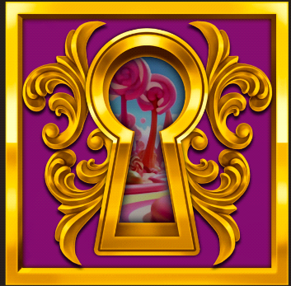 | Mint
Looping | yes
Duration | 5 sec
Description

Srs
8 hr
Symbol |  | Mint
Looping | yes
Duration | 0.5 sec
Description

Change to Special Wild (in free spins)
8 hr
Symbol | 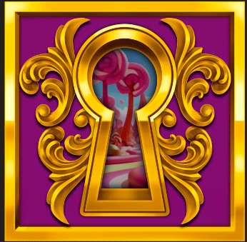 | Mint
Looping | no
Duration | 1 sec
Description | - Having the eye looking from behind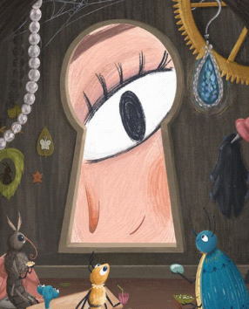  - Then alice coming from the side

Change into Border
8 hr
Symbol | 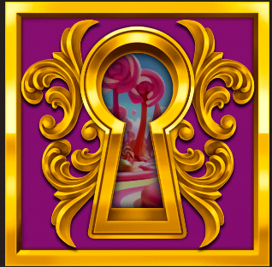 | Mint
Looping | no
Duration | 1 sec
Description | - Zoom into the key hole to another land and see the arch  - Then, zoom to the arch until the arch become the Border  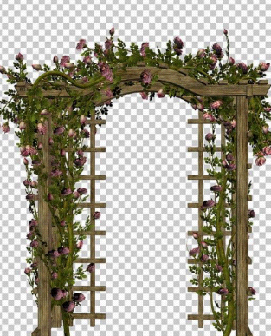

Border

Change into wild
8 hr
Symbol | (not designed yet)
Looping | no
Duration | 1 sec
Description | - Door close..  - Then, Hookah Smoke effect covers the symbol  - Morph into the Spicial Wild symbol (drunk effect)  - **same effect as SPECIAL WILD -> BORDER

Scatter
Setup/rigging for all SCATTER animations 4 hr

Idle
8 hr
Symbol | 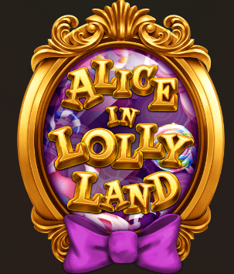 | Mint
Looping | yes
Duration | 5-10 sec
Description | - Light sweep  - Text wiggling  - Subtle Particle effect

Srs
8hr
Symbol |  | Mint
Looping | yes
Duration | 1 sec
Description | - Landing with blurry objects (inside the mirror) then become clearer  - Bouncing  - The text fade in

Trigger
16 hr
Symbol |  | Mint
Looping | no
Duration | 2 sec
Description | - Mirror shakes,, wiggle super hard  - Text moving  - Candy come out from the mirror floating around with glow effect

Win box
Symbol |  | Use the win box from 10000 years_v1
Looping
Duration | 1 sec
Description

Wind up
Symbol |  | Use the win box code from 10000 years_v1 – 1 hour to re-calibrate and export  1hr  4hr
Looping
Duration | 1 sec

Spin Counter

Design

Option2 :
- Start with full candy in tube glass
- One spin, shoot 1 candy ball off – so it’s like a lolly-dispensing machine which ejects 1 lolly each spin, with the last lolly being glowing and clearly special

Trigger: last candy flies to the middle of the screen then spins and explodes
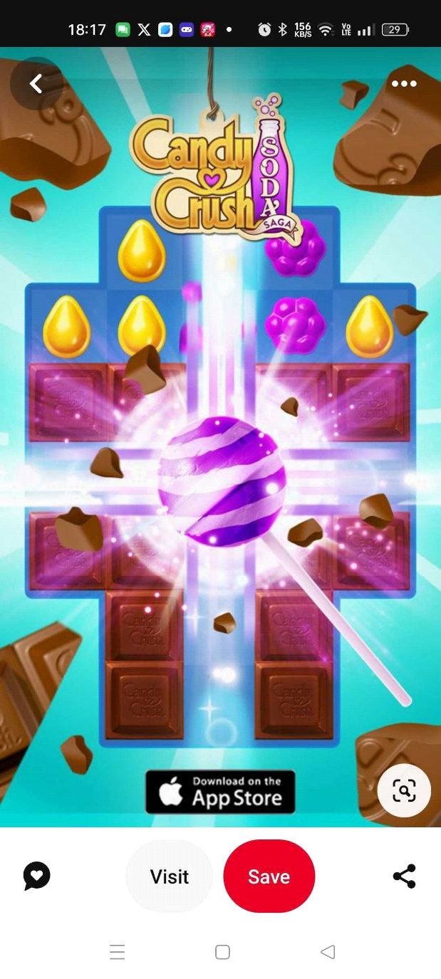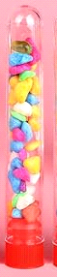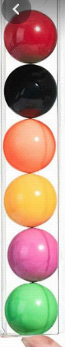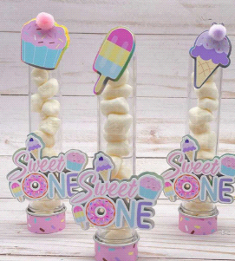

Add one to the spin count
8 hr
Symbol | (not designed yet) | Roong  Draw 5 hr  Setting 3 hr
Looping | no
Duration | 1 sec
Description | shoot 1 candy ball off

Trigger on tenth spin
4 hr
Symbol | (not designed yet)
Looping | no
Duration | 1 sec
Description | Will also require an animation over the reels – though this might be better achieved by combining animations and code

Reset back to full
4 hr
Symbol | (not designed yet)
Looping | no
Duration | 1 sec
Description

Background animations

